Our Century Tech journey

Context

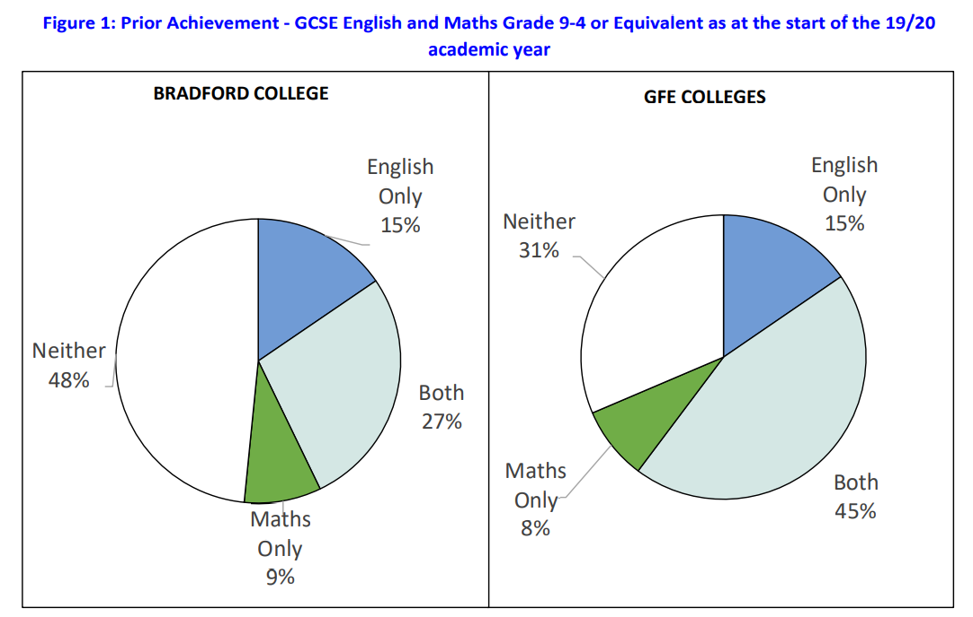

My name is Adrian, and I have worked at Bradford College for just over a year and I think it’s fair to say that it does present some unique challenges. A substantial number of learners – 48% - come to the college without a pass in both GCSE English and maths which is 17% higher than the sector average.

We have also had historically low high-grade achievement rates and so we decided that we needed a robust plan that would help learners progress and achieve the grades they need.

So, what is our plan?

We implemented a whole college approach to developing English and maths skills which we call our SOAR strategy. The 4 key pillars of this strategy are:
Why did we choose Century Tech?

We have always been keen to have an intervention approach which helps us to develop the skills that the students don’t yet have. Developing a truly individualised support package has been at the heart of our plans from the start. For example, we started to create our own videos and work packages and to curate other resources from the wider community so that if a student needed to work on a particular area we had multiple resources to support.

Century Tech seemed like the ideal solution to this problem. I have worked with Century Tech at other organisations I have worked at. In 2015 I was working at a college in Luton and we engaged with a UfI project which included Century Tech so I knew what it was capable of.

The appealing aspect to us at this college was the fact that the assessment identifies the skills gaps and the AI determines what content to push to fill in those gaps. The package works brilliantly as a supportive tool and complements the work that goes on in the classroom.

When did we implement it?

We decided to get Century Tech back in January 2020 but were going to wait until August 2020 to introduce it. When the situation changed in March we decided it was a good time to get it in early so that students had an opportunity to develop their English and maths skills during lockdown.

We had decided that we would no longer be delivering live face to face classes after the lockdown started and began the process of determining what predicted grades we were going to award. The English and maths team also developed a series of ‘master classes’ on Moodle which students could access and use to brush up and develop their skills on specific topics.

Whilst formal taught sessions would no longer be held to facilitate the huge task of predicting GCSE grades teachers would still be available to answer questions and to provide feedback on work undertaken. We also strongly encouraged students to use the platforms as we may take evidence from these to support the predictions we were making.

We monitored the engagement that students had with the college VLE and Century Tech and whilst initial engagement was very high this dropped off when the government announced that only work produced before lockdown was completed could be used.

Engagement with online learning

As part of our quality assurance of the predicted grades exercise, we told all students that they needed to take a ‘confirmatory’ assessment which was housed on Century Tech. We would not change grades based on this assessment, but it would allow us to have more confidence when we awarded the final proposed grades. Throughout this period to May we saw increased use of Century Tech and received lots of positive feedback from the students.

One of the highlights of this period was learning that our students had answered over 500,000 questions during the lockdown period, more than any other college on the platform. We wanted to keep students developing their skills and so they did this on Century.

2020/21 academic year

This year has been a challenging year in several ways. We always planned on running November resits for a larger number of students. Last year was the first year that the college did any November resits. This year we planned for all students streamed on to grade 3 resit provision the opportunity to sit the autumn series. We estimated in business planning that this would have been 750 students for English and 628 for maths.

That was pre-Covid!!!

When we returned to college in August we had dealt with a significant number of complaints from students about the grades they received (even though this had been a record year for results)

Many were aware that the government had promised that a resit was possible if they were unhappy with their grades and so we had a significant number opt to do the resit. When we looked at the numbers we decided to put all grade 2 and 3 learners through the resit and use this as an externally validated assessment point. This year we are very explicit with students that performance on the three assessment points is really important if we need to use Centre Assessed Grades again.

GCSE Assessment Points

Assessment Point | Dates | Marked by
DA1 | September 7-18 (CT) | Century Tech
AP1 | Autumn resits (November) | External
AP2 | w/c 21 January 2021 | Internal
AP3 | w/c 12 April 2021 | Internal
AP4 | Summer exams – May/June 2021 | External

In the end we entered 1300 students for maths and 1150 for English, way more than we expected. What usually takes 4 months to plan was done in 5 weeks! We managed to execute the plans in a Covid safe manner, spread over 4 sites and students using multiple entrances and exits. Despite Covid we had strong attendance although a significant number of students had to isolate during the exam period and ended up missing them.

A key challenge with the exams at this time (aside from the lack of planning time) whilst living through the pandemic were:
- the number of students who started late so having less time to develop their skills
- the number of students who weren’t attending online classes due to digital poverty
- the lack of teaching time since the start of lockdown – a lot of students were new to the college as well
- Keeping up with the non-starts and withdrawals
We made a big thing about centralised communication with the students about the assessment protocols for the year. As the head I designed a report with the MIS team that looked at highest previous grade, personal and college email addresses and phone numbers so that I could communicate directly with the students.

Century Tech was going to be our central support plank to address some of the above issues. If we could get students engaging directly with Century Tech then they had more opportunity to develop their skills outside the limited contact time we have with them in the class. It also tracks the progress of students through their work better than any other platform I have worked with.

How we drive engagement:

We use a variety of methods to drive engagement with Century Tech – the more that we can do to get students using it can only be beneficial. These methods have included sending centralised messages from myself using techniques taken from behavioural insights.
- Text messaging
- Emails
- Teams messages
- Reminders from vocational tutors
- Reminders from English and maths teachers
- Competitions
We never miss an opportunity to drive the message home that students need to be using Century Tech, sometimes this may be a bit Machiavellian…I have emailed the students directly when the plans for exams in Wales and Scotland changed to teacher assessments being used again for this year. I told the students that this may well happen here and if it did then we would be looking at engagement with Century Tech as a means of supporting our judgements for Centre Assessed Grades.

When we communicated with students about the GCSE November resits we always ended the message with a reminder about the importance of getting onto Century and developing their skills. I also set up an automatic reply on our central email inbox which we have called GCSE questions. This reply reiterated instructions for how to log on to Century Tech.

I have also taken reports from Century Tech, worked out the average number of nuggets completed and identified learners who, although they have engaged with Century, have done less than the average. I have then emailed those learners and pointed out that although it is brilliant that they have been on and completed some work on Century they are below the average number of nuggets completed by their peers.

We have just bought some Ipads and have identified the top users in terms of nuggets completed this term and done a presentation ceremony and used the promotion from this to encourage more students to engage

We have a great relationship with Century and Zoe, our key account manager, has been brilliant with requests for information. She has provided us with the key data sets that drive our reporting.

Student Feedback

- Century tech has been a means of revision for me over the past couple of months. It has helped me a lot in areas that I was struggling with, such as algebra and percentages. I have seen some improvements in those areas thanks to century tech nuggets.
- I find it really useful. I can use it to revise things I have already covered but it also explains new topics. I think that at revision time it will be my most useful tool to cover everything again.
- Hello, I try to use the century tec, a bit each week. I find this a very helpful way to learn. The nuggets are short, so they don`t get too boring. The videos are helpful and recap my English learning. I like that I can choose what I need to learn, or I can follow the recommend path.
- I find it very useful for English. I have learnt a lot and it is now one of the main ways I study English so thank you.
- I have been using century tech for my revision it has helped me and I’ve quickly got to know the topics of my weakest point to my strongest point.
Staff feedback

- I think it is a good tool as in nuggets are tailored to student needs. It provides a single platform that students can use rather than google a topic for videos and worksheets, which can be overwhelming. They can login anytime and work on what they need to develop and make the most of their learning. It is also helpful for teachers to have a quick glance at engagement and progress made.
- I have enjoyed using it, especially the planner to upload topics covered during session time for the students to work on independently but they will not be able to do this if they do not have access to technology. You can also see at a glance whether students have engaged with Century Tech or not which is also useful.
- My adult students are engaging with it and finding it really helpful to underpin and consolidate what they’re doing in class. It’s then given them a real boost in confidence and helping them to develop their understanding and improve performance in class and homework. Some of my 16-18 year old students lack motivation, but those who have used Century Tech have said that it’s ‘sick’.

Impact

This will be a key question for us going forward and the next step in our journey.

We have been able to track the engagement of the learners well. For example, I know that 70% of our 16-18-year-old students have logged onto Century tech and done at least some learning. The remaining 30% are lower level learners who struggle with the literacy skills to access CT on their own or learners who do not have access to IT equipment – a challenge that we are working to overcome as a college.

When we receive the results of the November resits we will run them through our system along with the engagement reports we have for CT through to the dates of the exams. We will then be able to analyse the impact that Century has had.

We will also do the same exercise after each of the assessment points so that we are able to get a holistic picture of impact.

